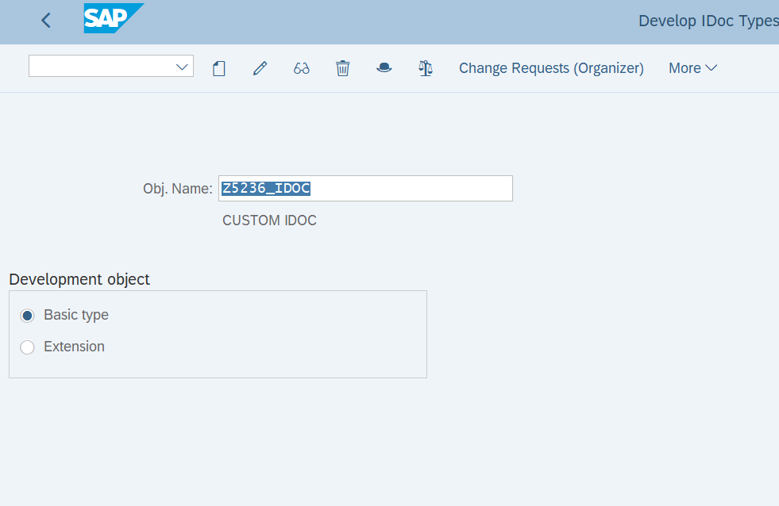

* **The system prompts you to enter a type of segment and its attributes.**

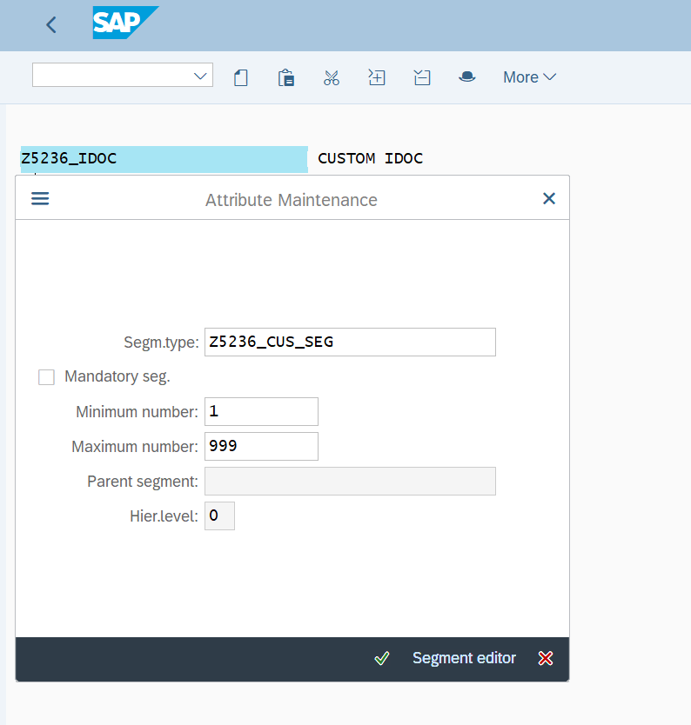

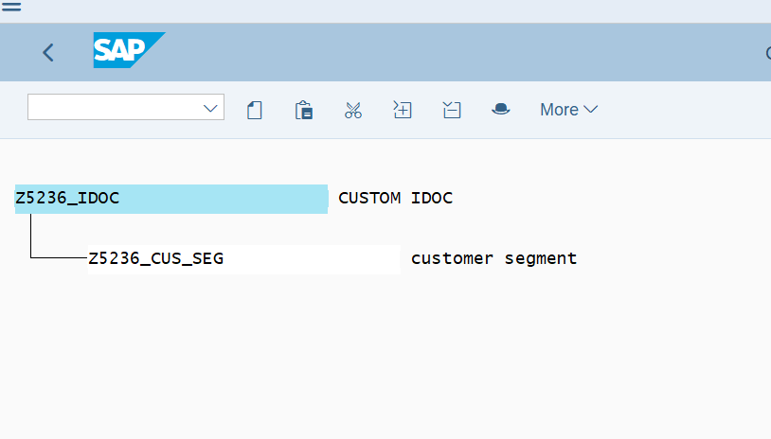

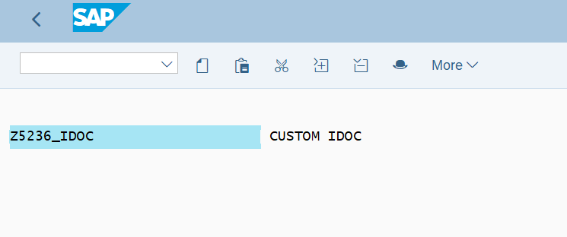

## ****Creation of IDoc Message Type ( WE81).****

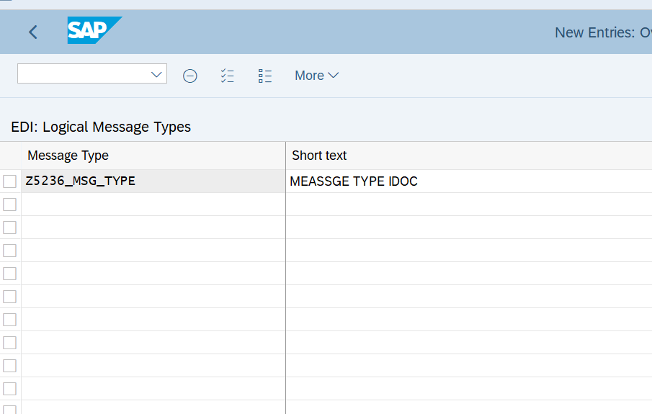

* **Assign message type Idoc type in we82.**

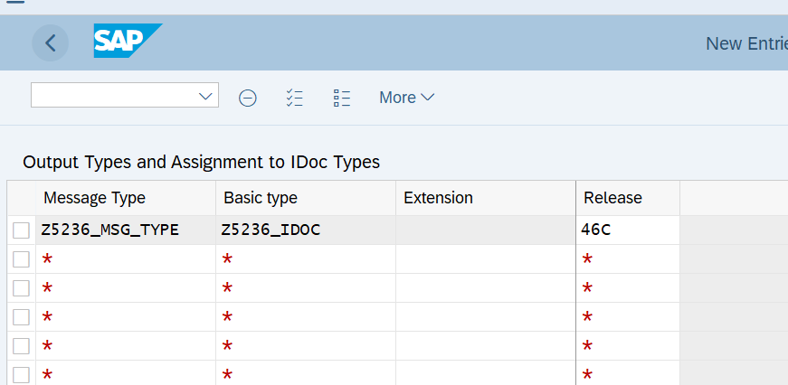

**Q2. Create a inbound function module to update the data in a custom table.**

**Below input output fields needed:**

**\*"*"Local Interface:**

**\*" IMPORTING**

**\*" REFERENCE(INPUT_METHOD) LIKE BDWFAP_PAR-INPUTMETHD**

**\*" REFERENCE(MASS_PROCESSING) LIKE BDWFAP_PAR-MASS_PROC**

**\*" EXPORTING**

**\*" REFERENCE(WORKFLOW_RESULT) LIKE BDWF_PARAM-RESULT**

**\*" REFERENCE(APPLICATION_VARIABLE) LIKE BDWF_PARAM-APPL_VAR**

**\*" REFERENCE(IN_UPDATE_TASK) LIKE BDWFAP_PAR-UPDATETASK**

**\*" REFERENCE(CALL_TRANSACTION_DONE) LIKE BDWFAP_PAR-CALLTRANS**

**\*" TABLES**

**\*" IDOC_CONTRL STRUCTURE EDIDC**

**\*" IDOC_DATA STRUCTURE EDIDD**

**\*" IDOC_STATUS STRUCTURE BDIDOCSTAT**

**\*" RETURN_VARIABLES STRUCTURE BDWFRETVAR**

**\*" SERIALIZATION_INFO STRUCTURE BDI_SER**

**\*" EXCEPTIONS**

**\*" WRONG_FUNCTION_CALLED**

**STEP 1:FUNCTION GROUP CREATION (SE80).**

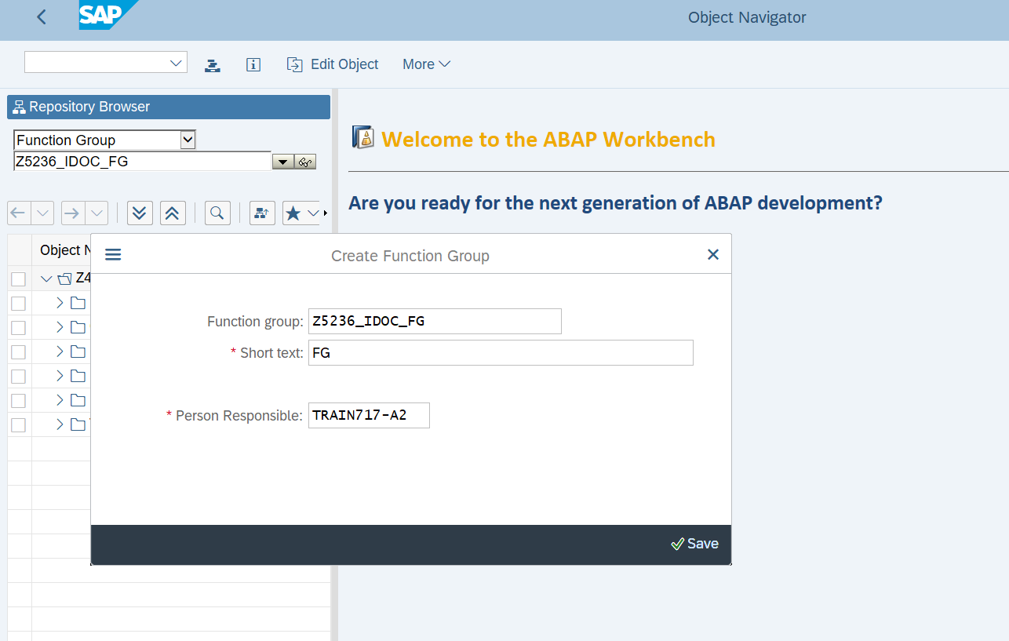

**FUNCTION MODULE(SE37):**

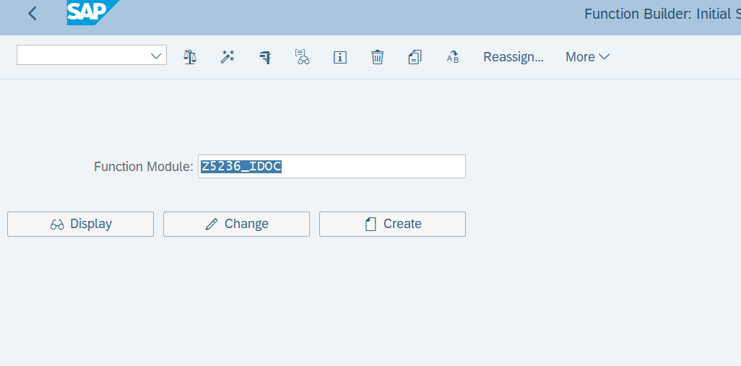

* **Function module import, export and table parameters:**

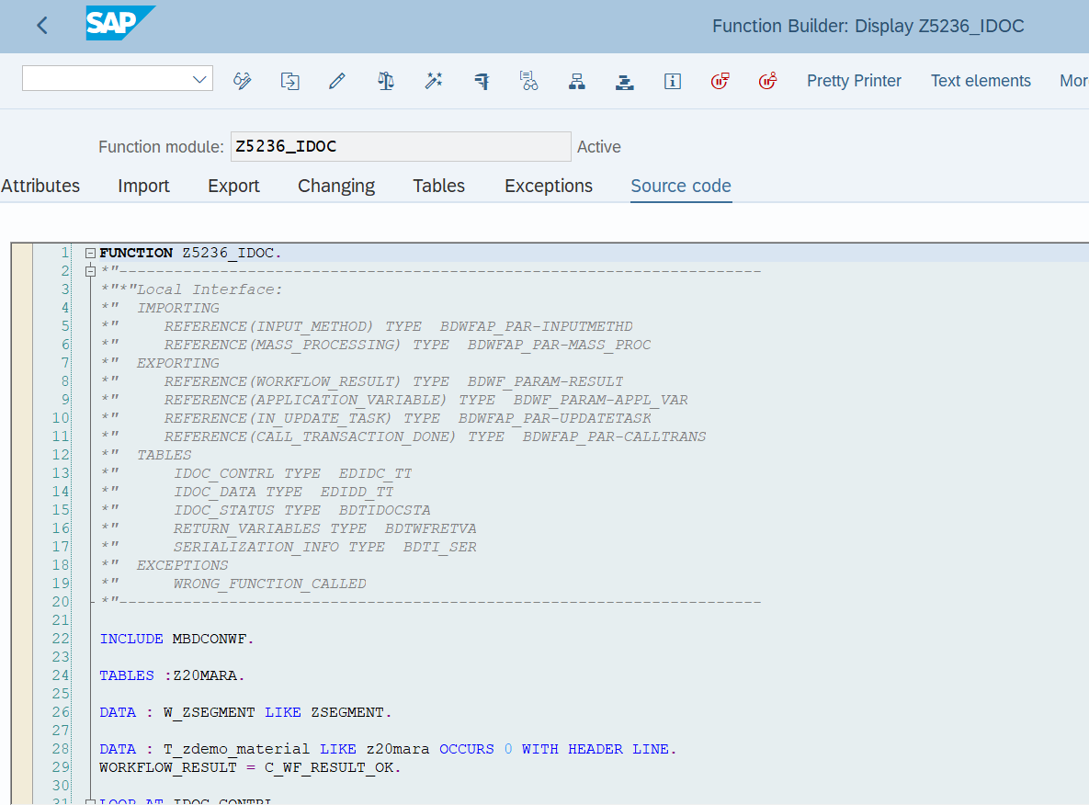

## ****Assign FM(Function Module) to IDoc Type and Message Type(WE57).****

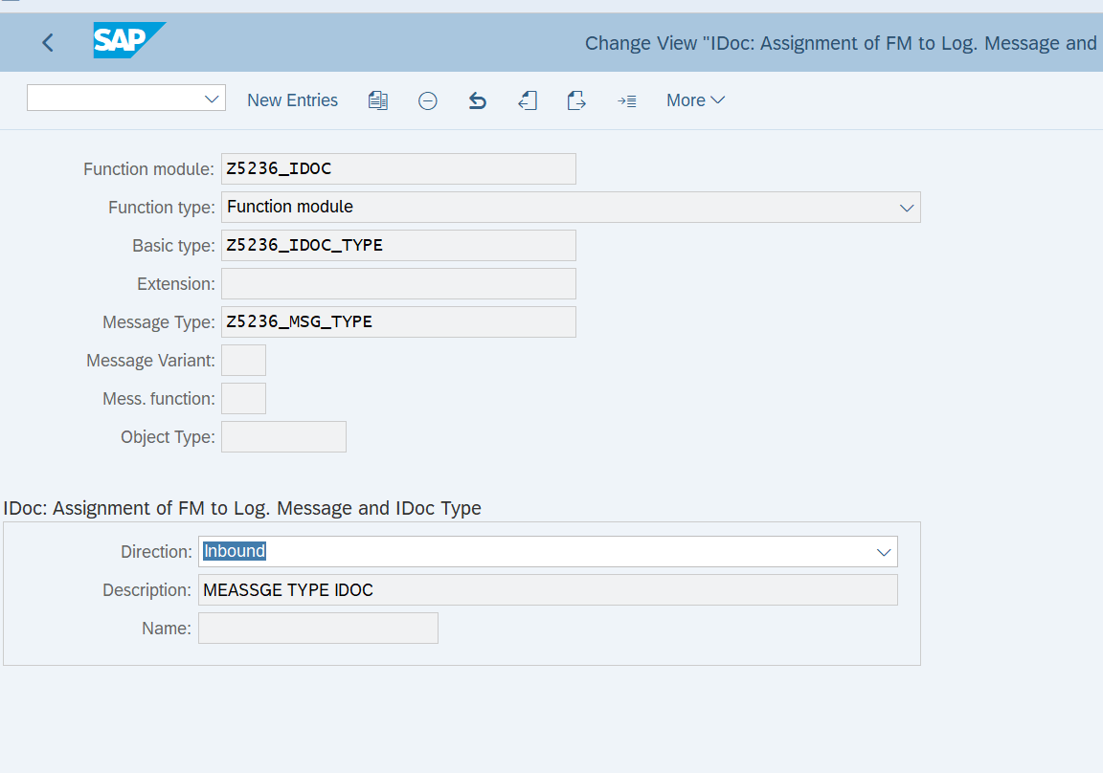

## ****Define Inbound FM Characteristics(BD51):****

* + **Take transaction code BD51**
  + **Click New Entries to create a new type of message**

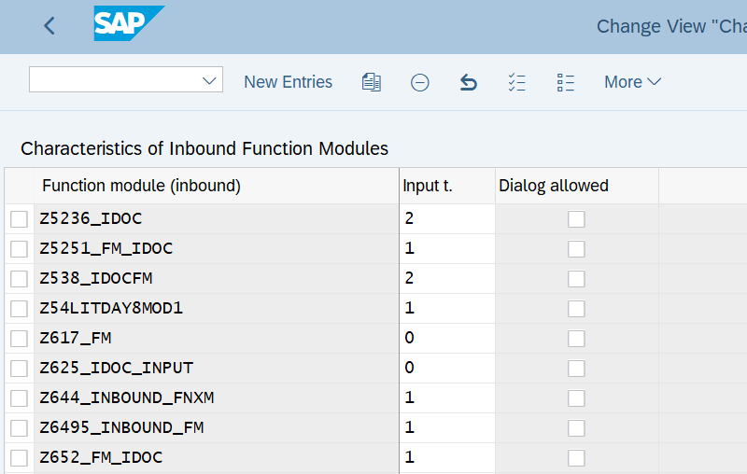

## ****Create Inbound process code (WE42):****

* + - **Go to the WE42 transaction code**
    - **Click the New Entries button to create a new Inbound process code.**
    - **Fill in details**
    - **Save it and go back there.**

## 

## 

**Q3. Create a testing Scenario where we can upload data using Standard IDOC.(MATMAS, CREMAS etc)**

**Check in the system after updatation.**